**Obi Chioma Blessing**

[**Obi.chioma@womentechsters.org**](mailto:Obi.chioma@womentechsters.org)

**WT/21/173**

**GitHub: https://github.com/blexcel/Practical-Activity/blob/master/Obi%20Chioma%20Blessing%20Practical4.docx**

**Practical Activity 4**

This week’s Practical Activity will be based on Bash script Programming. As a system Administrator in the near future, you will be expected to understand the structure of Bash Scripts and also you might encounter this type of questions in an interview scenario.

**Write a shell script to validate password strength when a user enters. Here are a few assumptions for the password string.**

* Length – minimum of 8 characters.
* Contain both alphabet and number.
* Include both the small and capital case letters.

If the password doesn’t comply with any of the above conditions, then the script should report it as a <Weak Password> if the password complies with the conditions, it should echo <Strong Password Secure User>

1. **Write the code in a file created in your home directory and call it auntentic.sh**

In my home directory, I created a script called authentic using **touch authentic.sh**

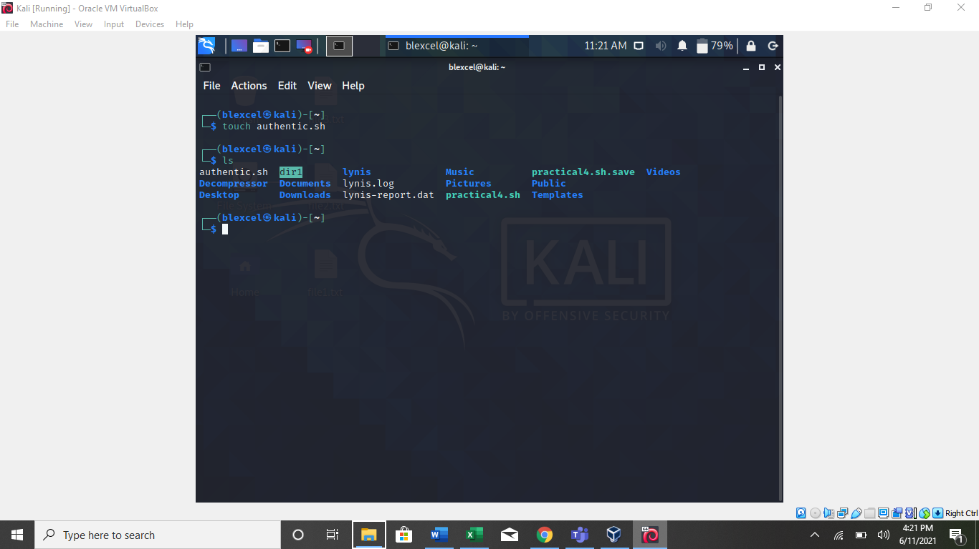

1. **Just the same way we have created scripts execute it and use nano editor to add your code.**

With **nano authentic.sh,** I opened the editor so as to write the code which will peform the operation.

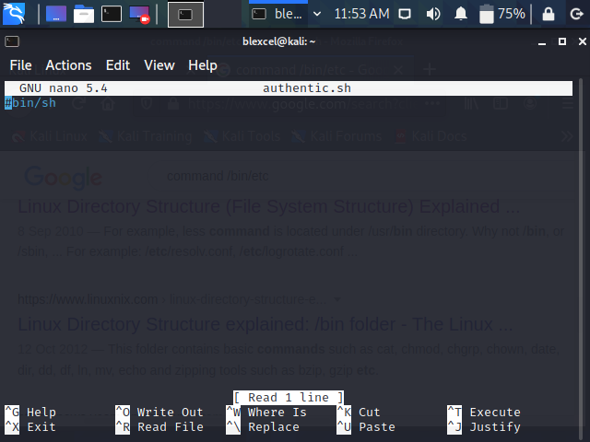

1. **After words Screenshot, your Code Paste it in a word Document as part one of your Report.**

In the editor, I used the follow code:

#!/bin/bash

echo -n "Enter a password : "

read password

LEN=$(echo ${#password})

if [ $LEN -lt 10 ]; then

echo "$password is smaller than 10 characters"

else

if [[ $(echo "$password" | awk '/[a-z]/ && /[A-Z]/ && /[[:punct:]]/') ]]>

echo "$password is a strong password"

else

echo "$password is a weak password"

fi

fi

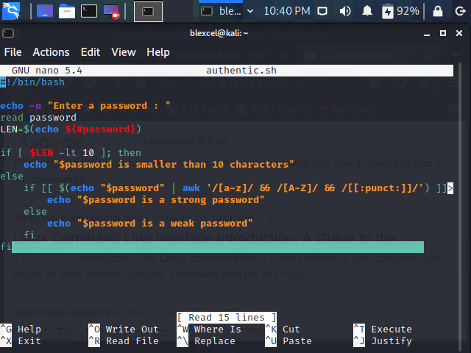

1. **Also test your script by typing different passwords and screen shot the output from your terminal add to your report document.**

Finally, using the command **./authentic.sh** I tested the strength of different password.

